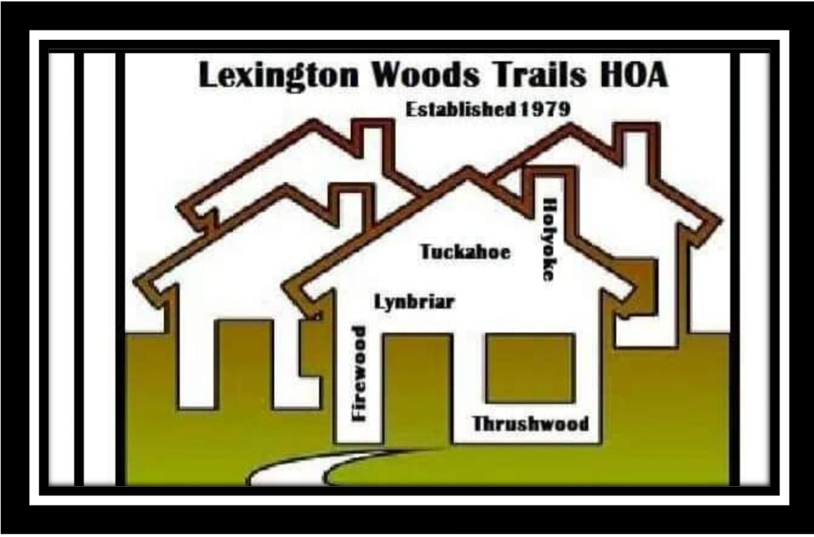

RECORDS RETENTION, INSPECTION & PRODUCTION POLICY
LEXINGTON WOODS TRAILS COMMUNITY ASSOCIATION, INC.
. P.O.Box 1959
Spring, Texas 77383
832-447-3146

WHEREAS, Section 209.005(i) of the Texas Property Code requires property owners associations to adopt a records production and copying policy record it as a dedicatory instrument; and

WHEREAS, Section 209.005(m) requires property owners associations to adopt and comply with a document retention policy;

NOW THEREFORE, BE IT RESOLVED THAT:

The following POLICY REGARDING RECORDS RETENTION, INSPECTION & PRODUCTION is hereby adopted:

RECORDS RETENTION:

- Certificates of Formation, Articles of Incorporation, Bylaws, restrictive covenants and any amendments thereto shall be retained permanently;
- Financial books and records shall be retained for seven (7) years;
- Account records of current owners shall be retained for five (5) years;
- Contracts with a term of one year or more shall be retained for four (4) years after the expiration of the contract term;
- Minutes of meetings of the Owners and the Board shall be retained for seven (7) years; and
- Tax returns and audit records shall be retained for seven (7) years.

RECORDS INSPECTION & PRODUCTION:

An Owner, or a person designated in a writing signed by the Owner as the Owner's agent, attorney or certified public accountant, may make a request to access the books and records of the Association, provided that such Owner or designated agent submit a written request by certified mail return receipt requested, which contains sufficient detail to identify the records being requested.

The Association may require advance payment of the estimated costs of compilation, production and reproduction of the requested information. If such advance payment is required, the Association shall notify the requesting owner in writing of the cost.

The Association will respond to the Owner's request in writing within ten (10) business days of receiving the request. If the Association is unable to produce the information within ten (10) business days, the Association must provide the requestor written notice that: (1) informs the requestor that the Association is unable to produce the information before the 10th business day; and (2) states a date by which the information will be sent or made available for inspection to the requesting party that is not later than the 15th business day after the date of the original response from the Association.

Absent a court order or the express written approval of the owner whose records are the subject of the request, the Association will not allow inspection or copying of any records that identify the violation history of an individual owner, an owner's personal financial information, including records of payment or nonpayment of amounts due the Association, an owner's contact information (other than the owners' address), or information relating to an employee of the Association, including personnel files.

The Association hereby adopts the following SCHEDULE OF CHARGES for the production and copying of records:

Copies: $.10 per page for standard paper black and white copies; $.50 per page for oversize paper or color copies.

Electronic Media: $1.00 for each CD; $3.00 for each DVD

Labor: $15.00 per hour for actual time to locate, compile and reproduce records (no charge for requests for 50 or fewer pages)

Overhead: 20% of the total Labor charge (no charge for requests for 50 or fewer pages)

Miscellaneous: The Association may charge for actual costs incurred in responding to the request, including costs for labels, usb drives, boxes, folders, postage and/or shipping.

IN WITNESS THEREOF, this Policy is executed on the 27th day of April, 2023.

________________________________________________

________________________________________________
_________________________, President
Lexington Woods Trails Community Association, Inc.

STATE OF TEXAS §
§
COUNTY OF Harris. §

BEFORE ME, on this day personally appeared Wanda Wilcox, the President of Lexington Woods Trails Community Association, Inc. , known by me to be the person whose name is subscribed to the foregoing instrument, and acknowledged to me and s/he executed the same for the purposes and consideration therein expressed and in the capacity therein and herein stated and is the act and deed of said corporation.

Given under my hand and seal of office, this ______ day of ______, 2023.

______________________________________________
Notary

CERTIFICATION

STATE OF TEXAS §
§
COUNTY OF _____ §

I, Wanda Wilcox, the undersigned, hereby certify: That I am the duly elected and acting President of Lexington Woods Trails Community Association, Inc. , a Texas nonprofit organization and that the foregoing constitutes the Records, Retention and Production Policy, as duly adopted at a property noticed Meeting of Directors held on ____ day of _____ 2023 and further approved by a quorum of Directors present.

IN WITNESS WHEREOF, I have signed in my capacity on this ____day of ____, 2023.

________________________________________________

________________, President

STATE OF TEXAS §
§
COUNTY OF Harris. §

BEFORE ME, on this day personally appeared Wanda Wilcox, the President of Lexington Woods Trails Community Association, Inc. , known by me to be the person whose name is subscribed to the foregoing instrument, and acknowledged to me and s/he executed the same for the purposes and consideration therein expressed and in the capacity therein and herein stated and is the act and deed of said corporation.

Given under my hand and seal of office, this ______ day of ______, 2023.

______________________________________________
Notary

